**System Manual**

**Process flow**

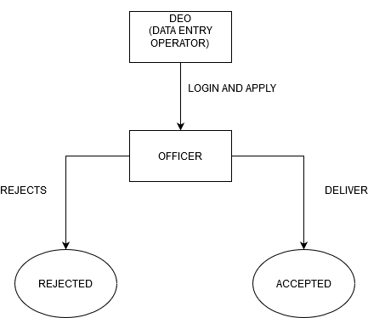

Login to <https://tathyasathi.bangla.gov.in/configure/> as “WB000168” (Service Definer) password as “Bengal@123”

Click Manage Service (top left of page) and then click “Create New Service”.

Then fill up “Definition” (first tab) as shown below.

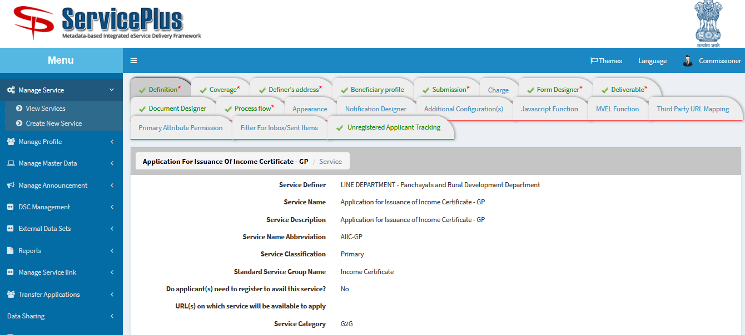

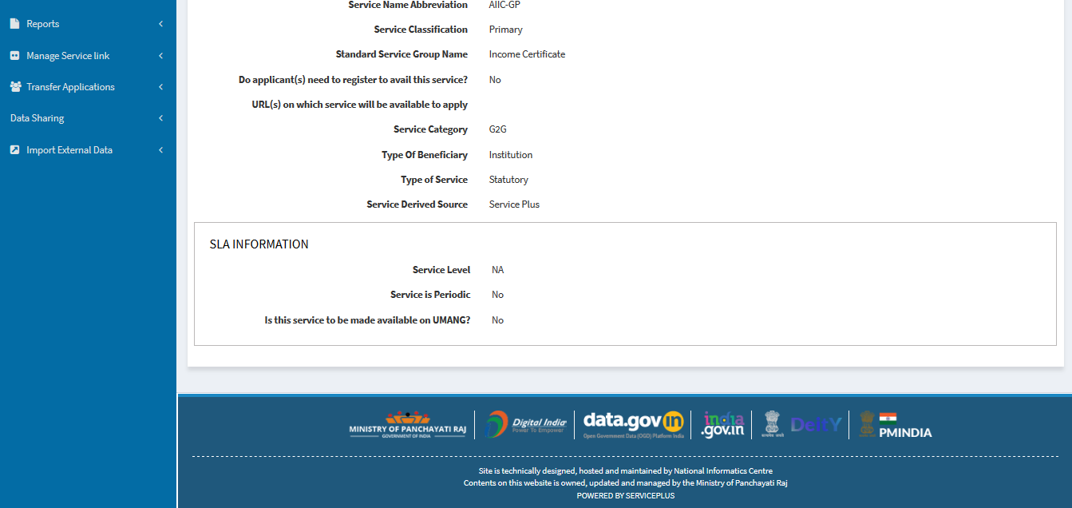

Click “Submit” button.

Next “Coverage” tab, take it as Rural Service, type of area as “Rural” & then Service Provided By “Gram Panchayat”. After that in service coverage, select all should be checked and click show child respectively till end. Then click “Add Value” button.

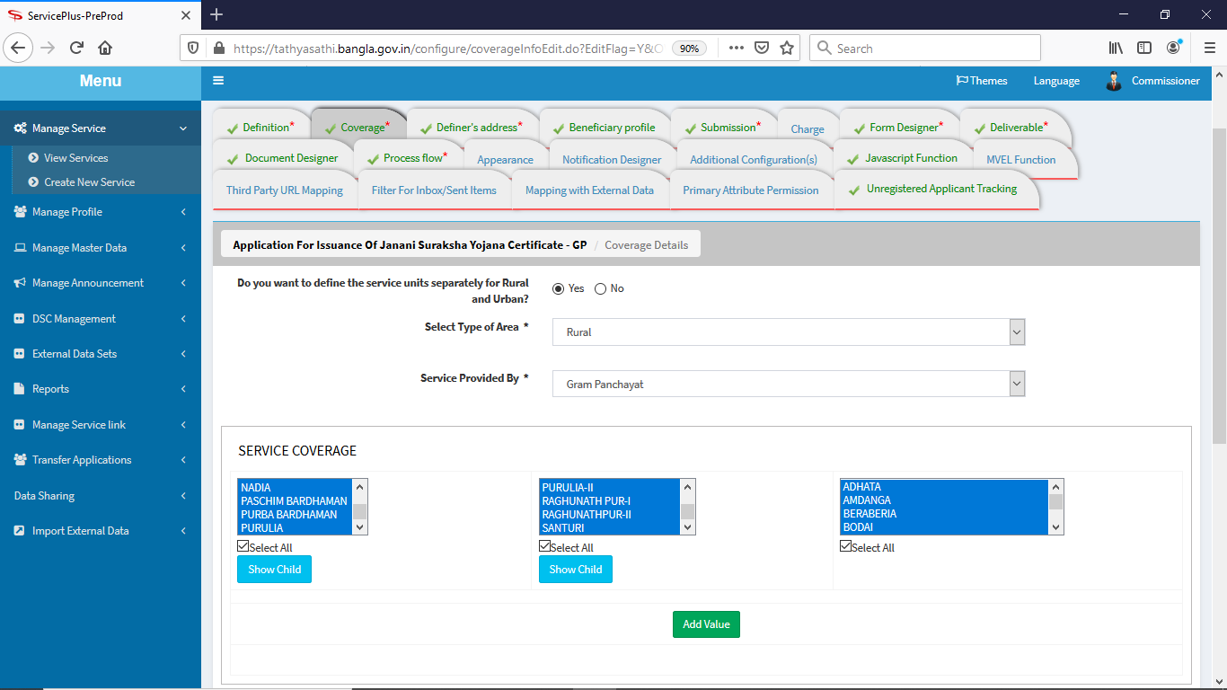

**‘Selected List(s) of Service Unit(s)’** will be shown below. Then checked “Select All” and click “Submit” button.

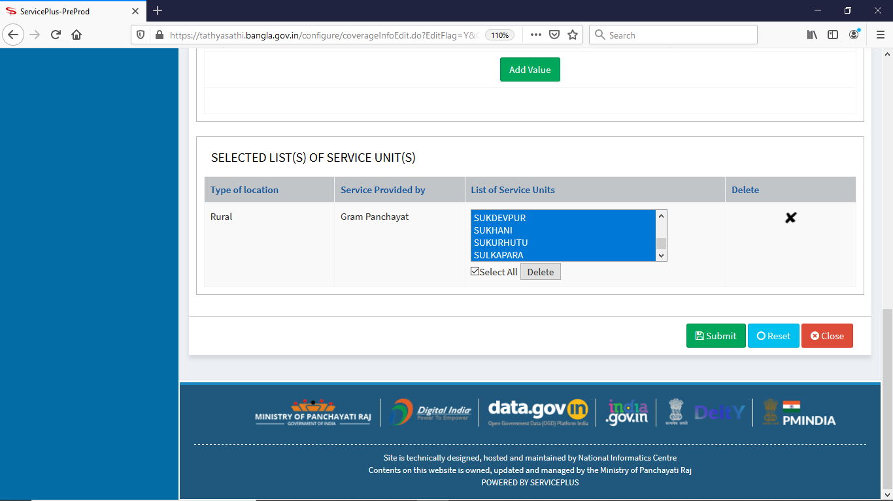

Then “Definer’s address” tab will be shown like this:

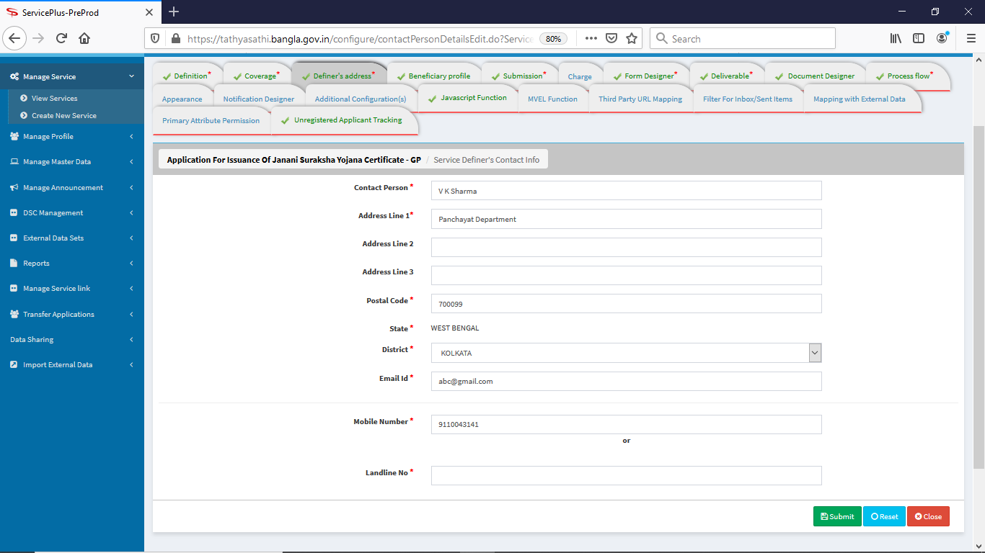

Click “submit” button.

“Beneficiary profile” tab will be shown like this.

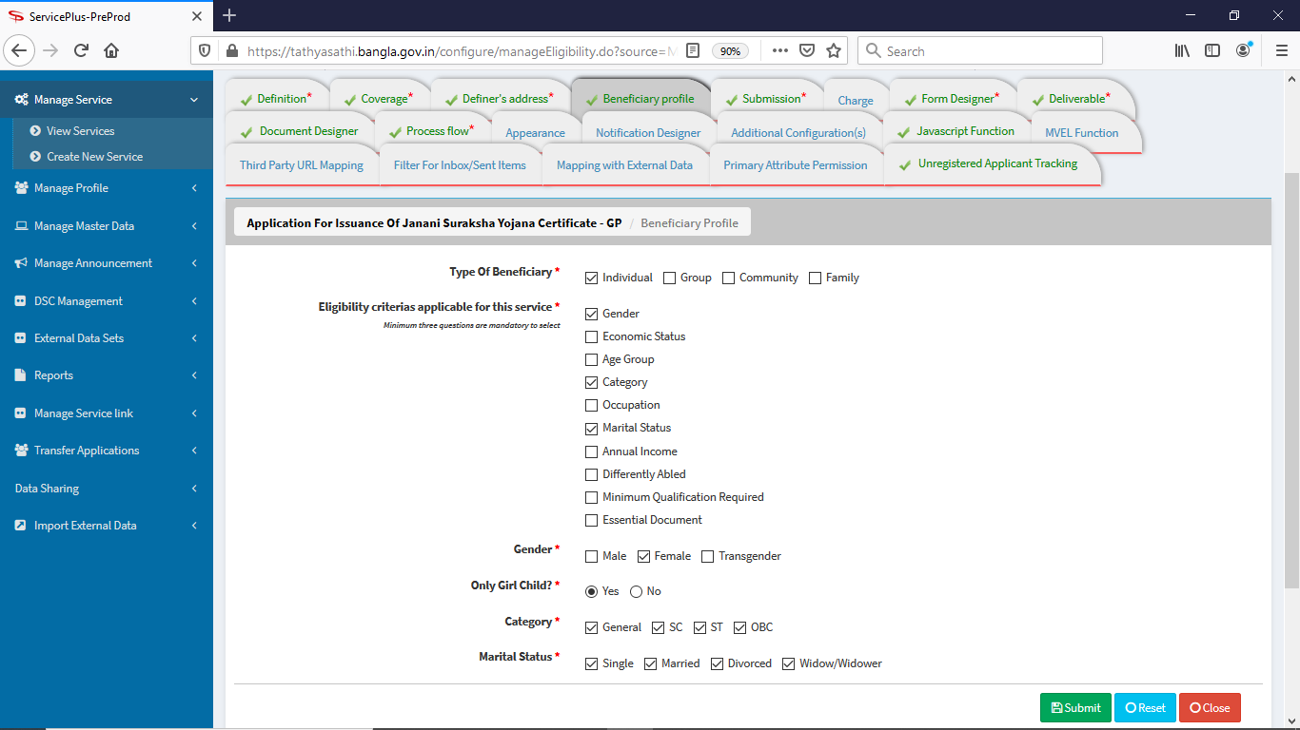

Click “submit” button.

“Submission” tab will be filled as below: 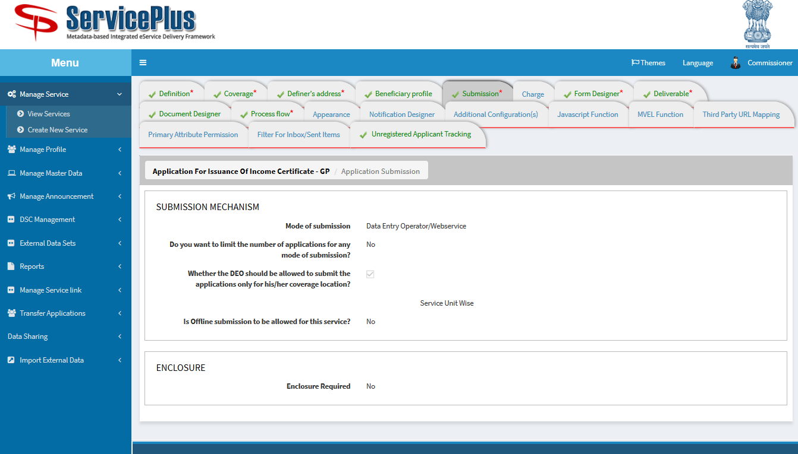

Click “Submit” button.

Next go to “Form Designer” tab. Click “Add new form template” filled up as shown below. Click “proceed” button.

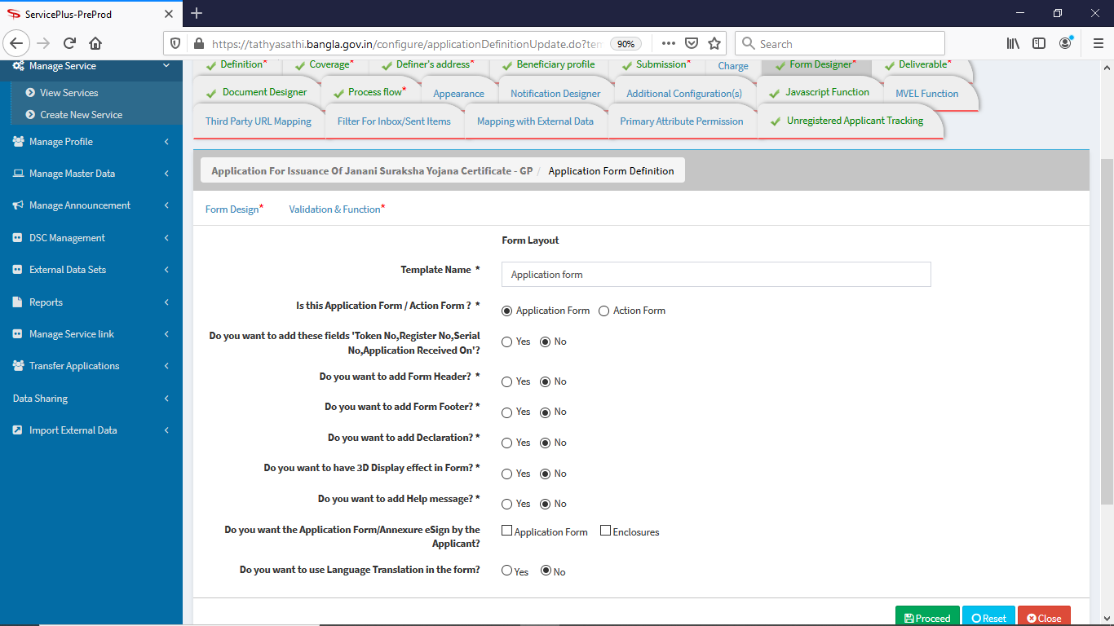

After that the “Form Designer” tab will be designed as given below.

Name of person, Guardian’s Name, Amount in words should be character with special character included “space” only.

Name of village, Post Office, P.S., Document No. Should be alphanumeric with special character included comma, /, _, - space.

Income of the family should be in number only.

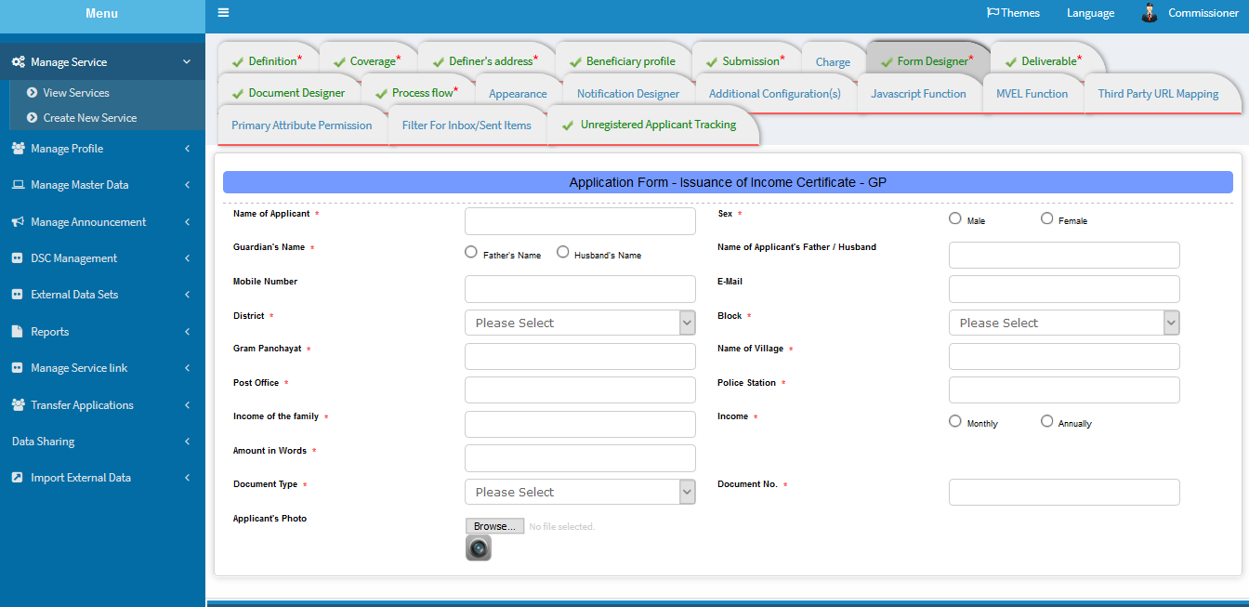

“Deliverable” tab should look like as under:

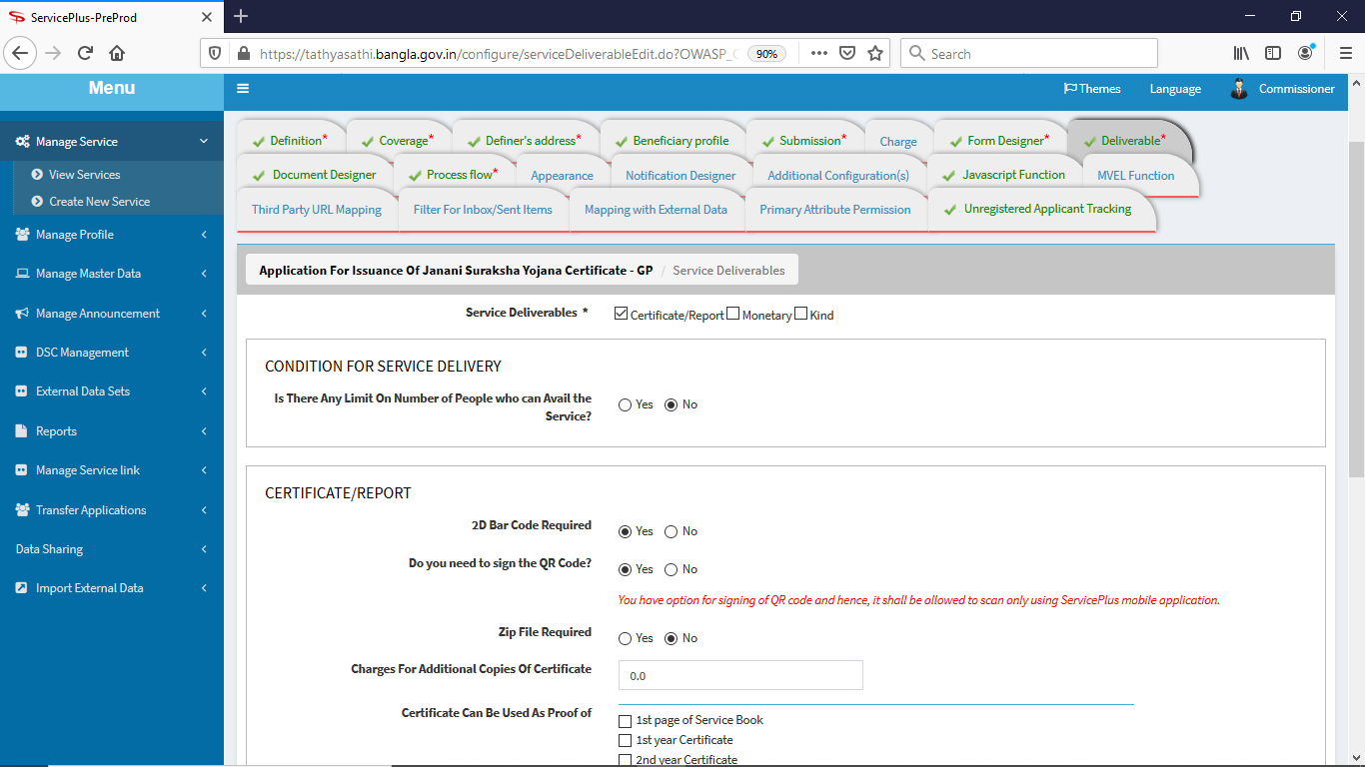

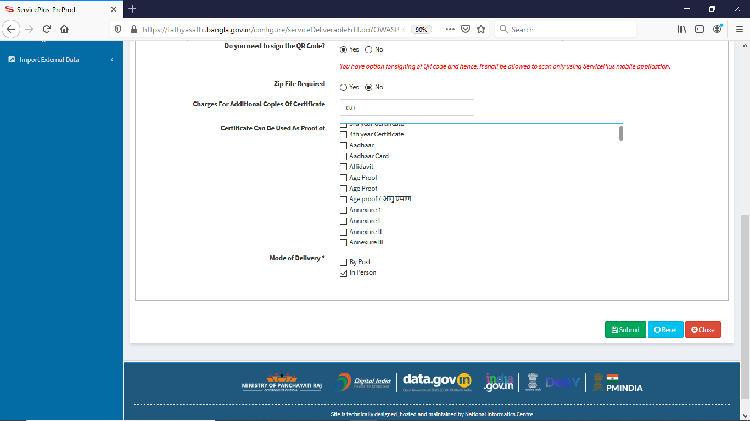

Click “Submit” button.

Click “Add New Template” in “Document Designer” tab, give ‘Template Name’ as “Income Certificate” it will be filled like:

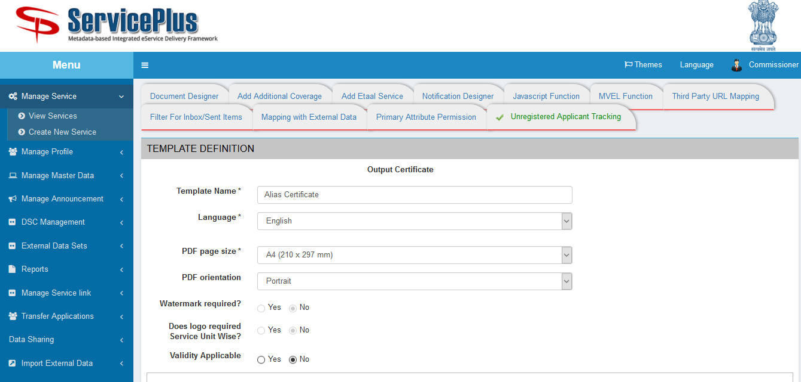

In “BARCODE PARAMETERS”, “Application Attributes” are added as per data of output certificate decorated as like shown below.

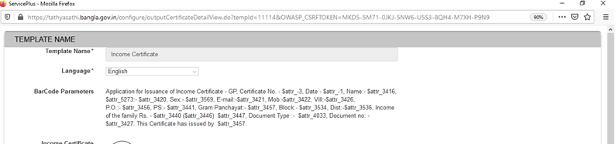

Sample certificate of Issuance of Income is given from department (Murshidabad dist., WB Govt.) is as under:

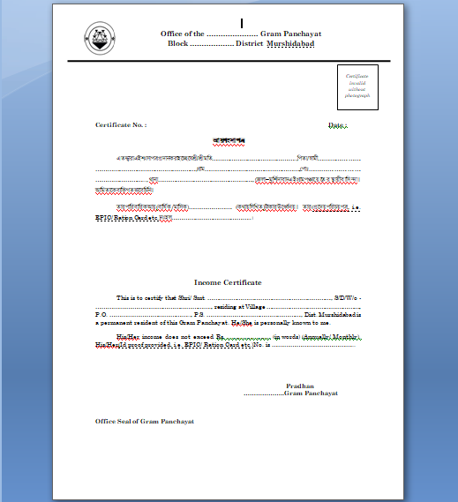

After design output certificate & adding Application Attributes variable & adding Barcode value in “**Template Layout”** the page looks like:

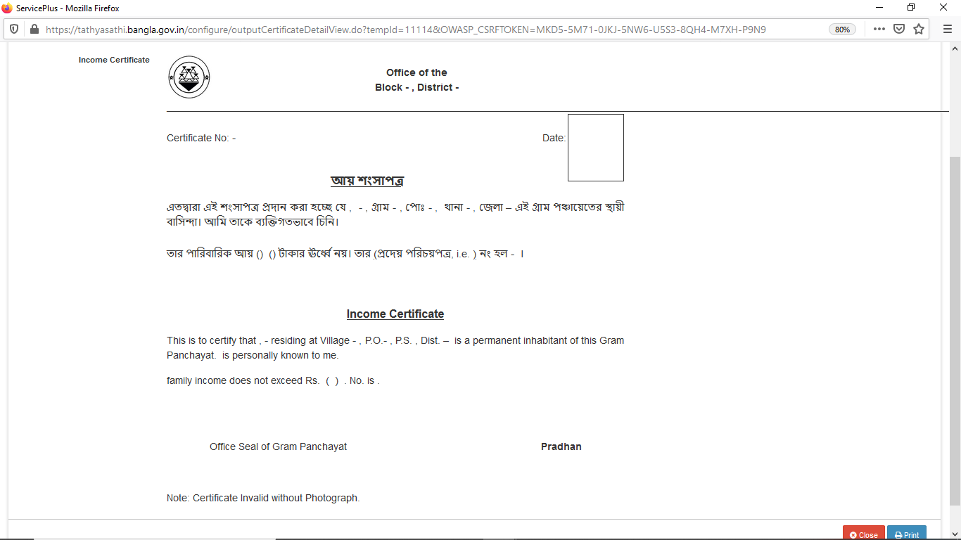

Now “Submit” form.

Click “Add New Template” in “Document Designer” tab for adding ‘Template Name’ as “Acknowledgement Notification”, it will be filled like:

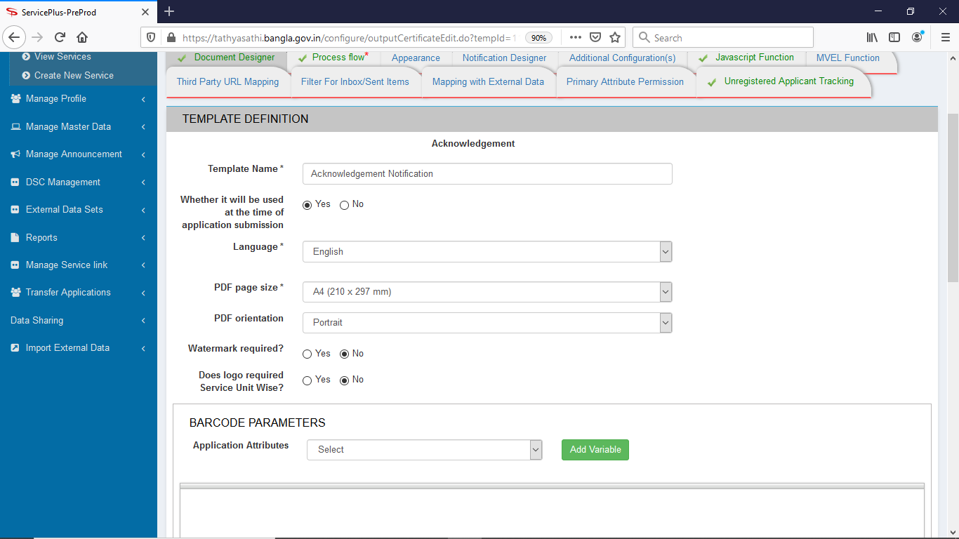

Designed the form and ‘Add Variable’ of “Application Attributes” & will be shown as under:

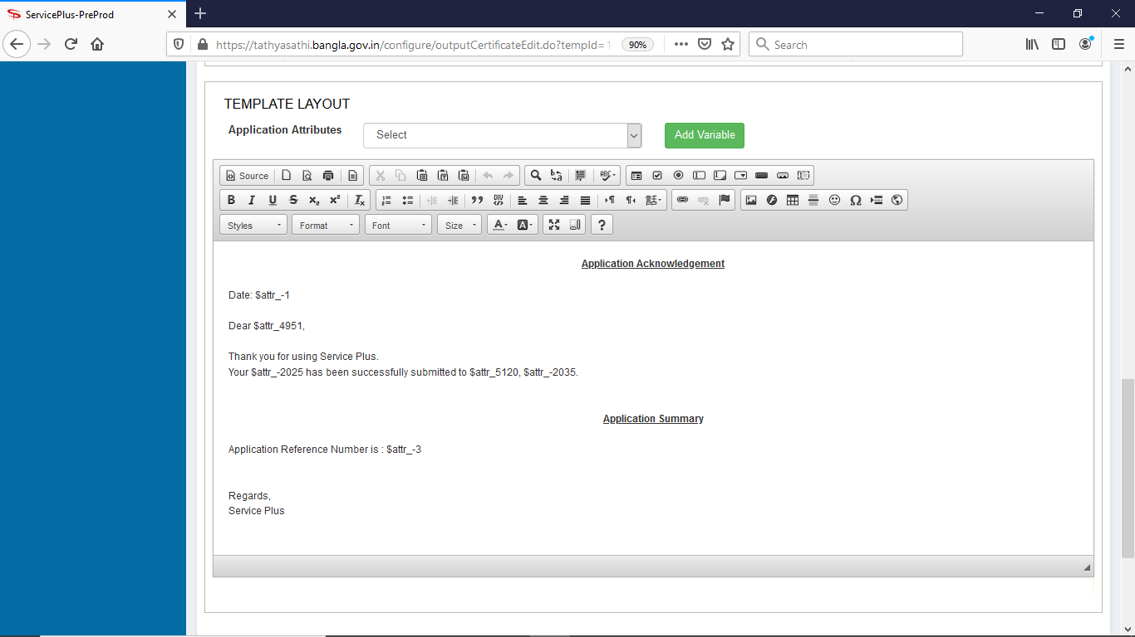

Go to “Process Flow” tab. Click on “Assign Department/Designation” menu

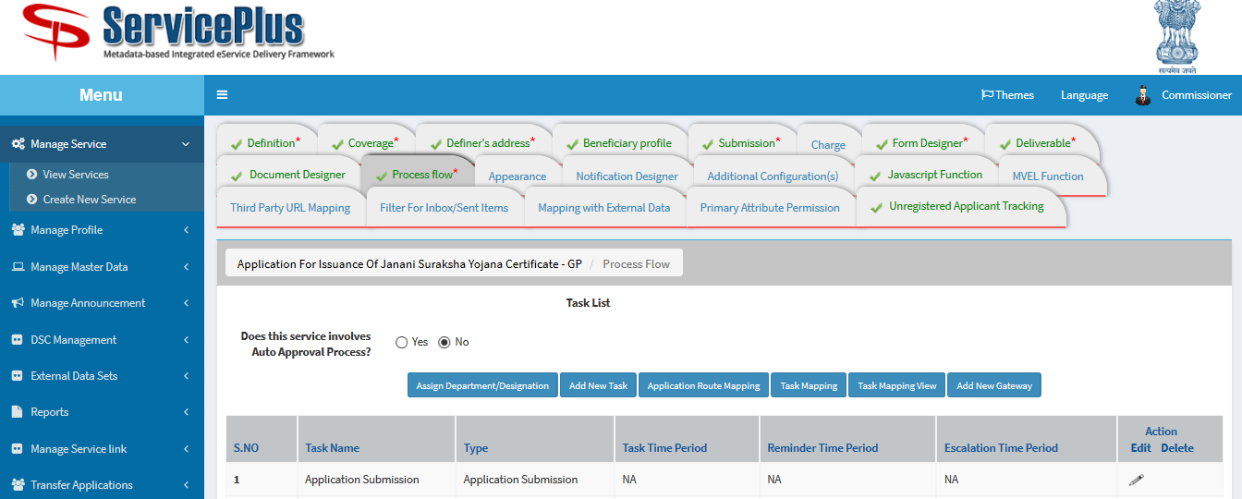

After clicking on “Assign Department/Designation” menu, a pop –up comes & fill the pop–up page like below:

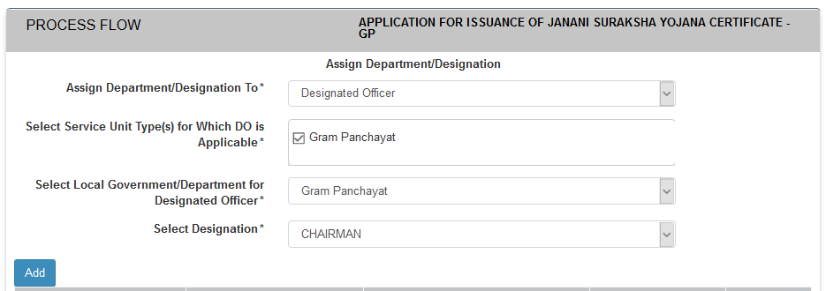

Then click “Add” button. After adding the page will be like below. Click “Submit” button.

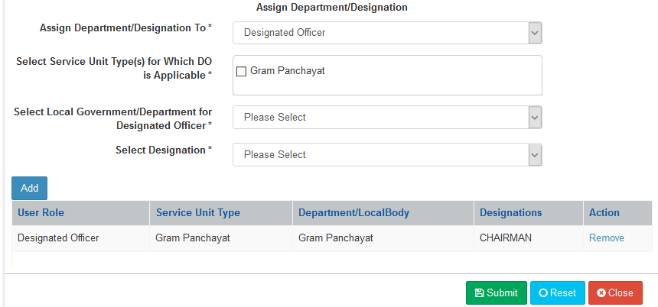

Task Name “Application Submission” click on “Edit” button, & fill like this:

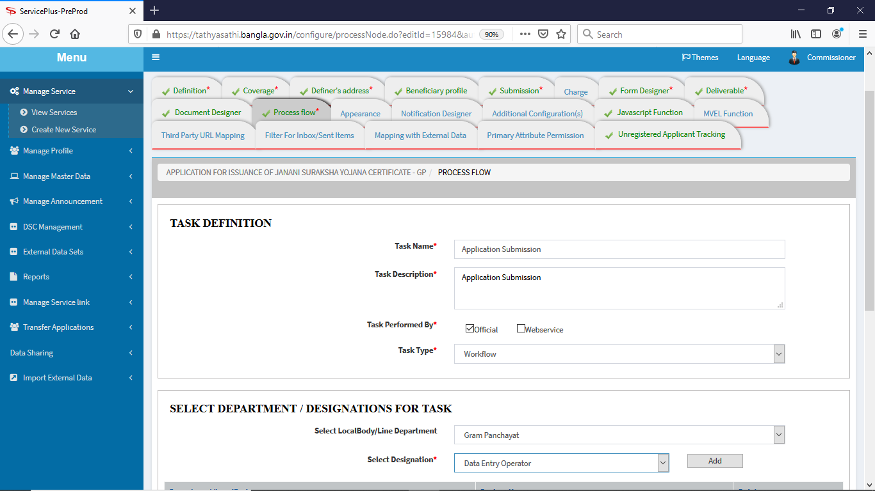

Then click “Add”

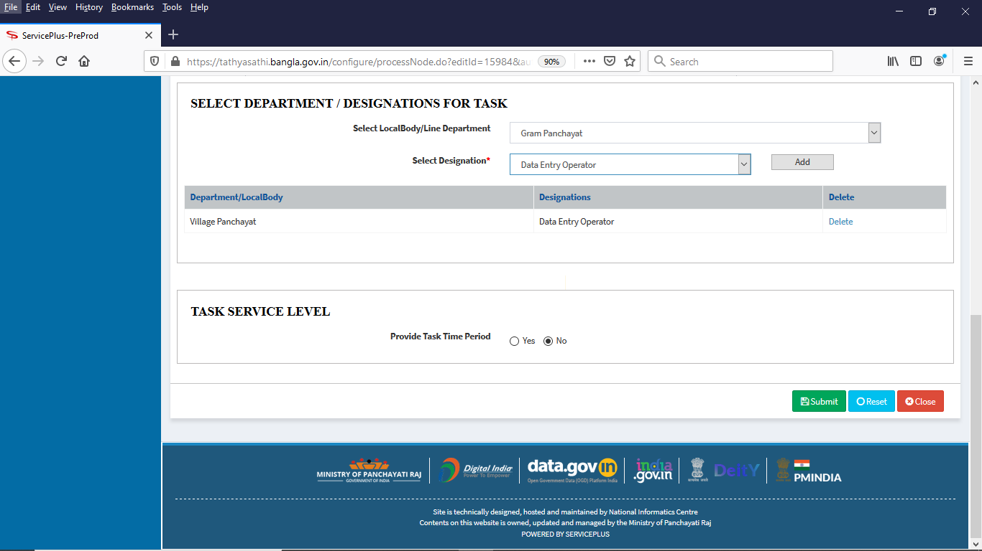

Click “Add New Task” for Issuance Authority

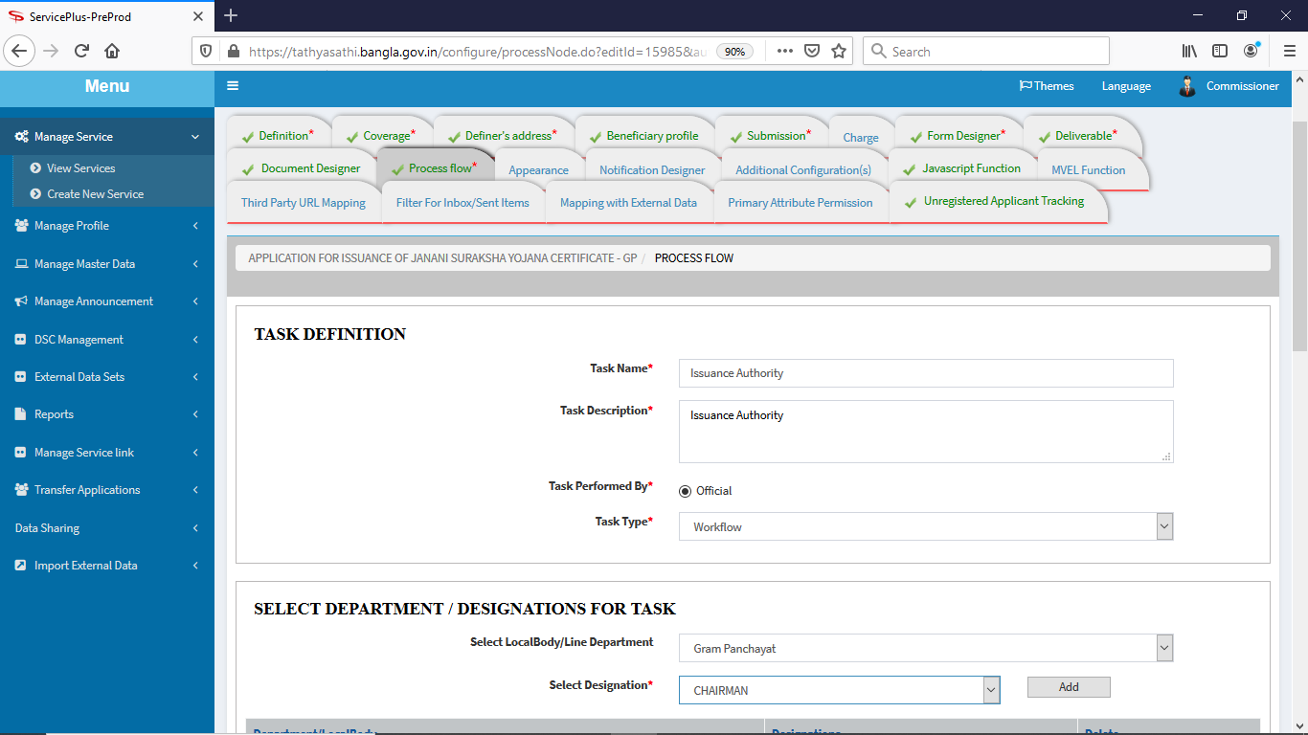

Click “Add” button

Fill like this & uncheck ‘Display Peers’. Then click “Submit”.

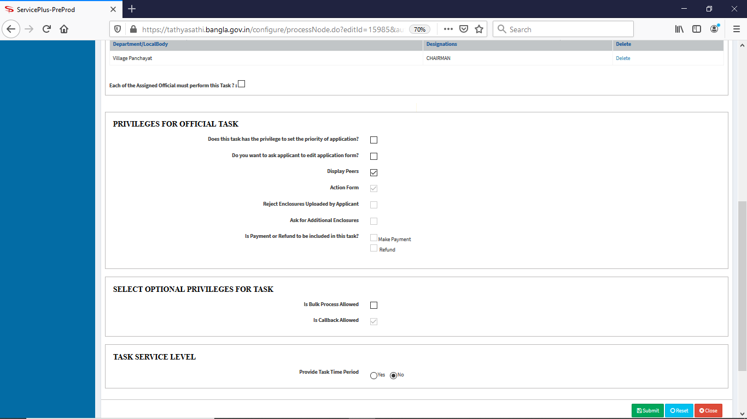

Again do same for “Dispatcher Task”, as shown below:

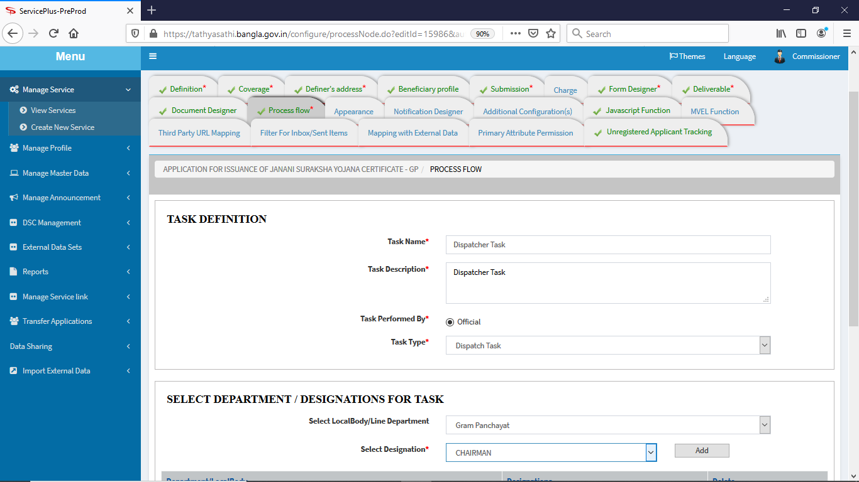

Click “Add”

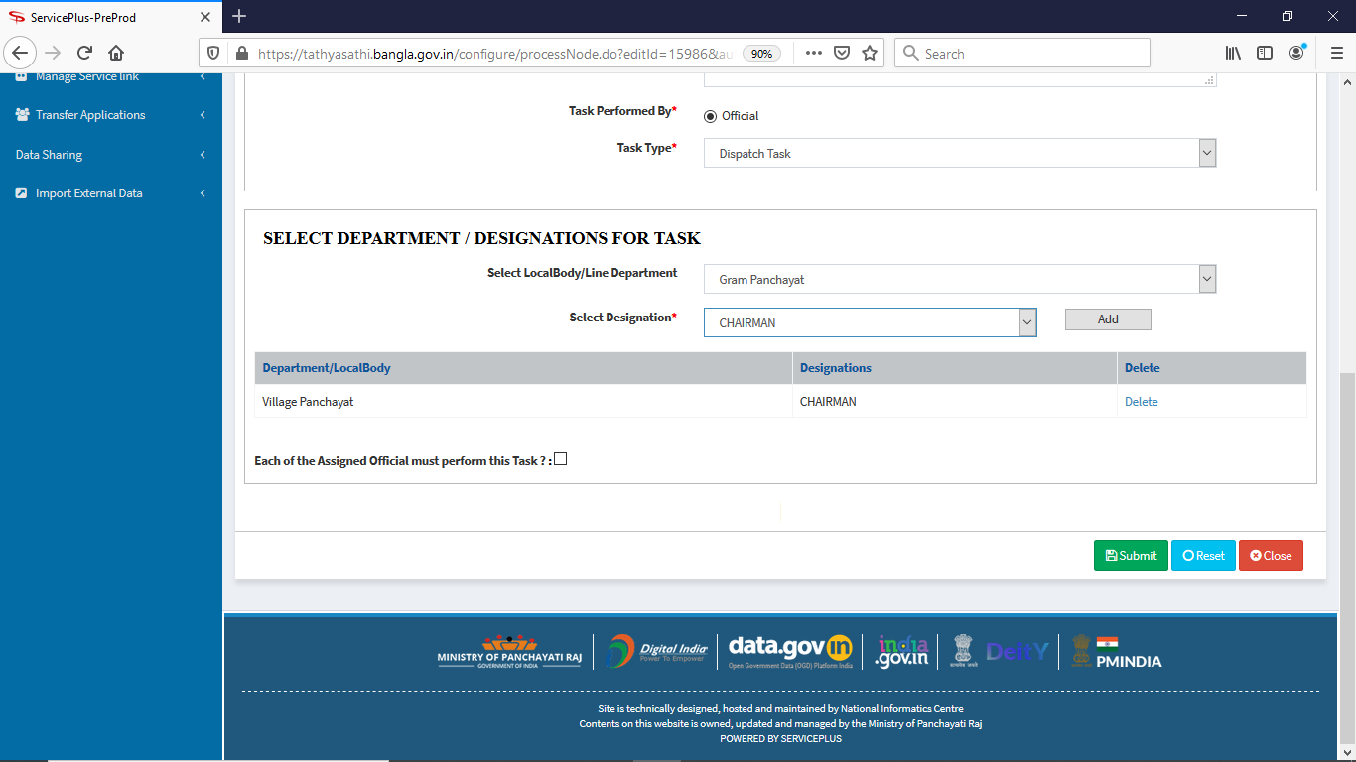

Click “Submit” button.

Now click to “Task Mapping” by checking (From & to) clicking “+” Action task will be mapped as below:

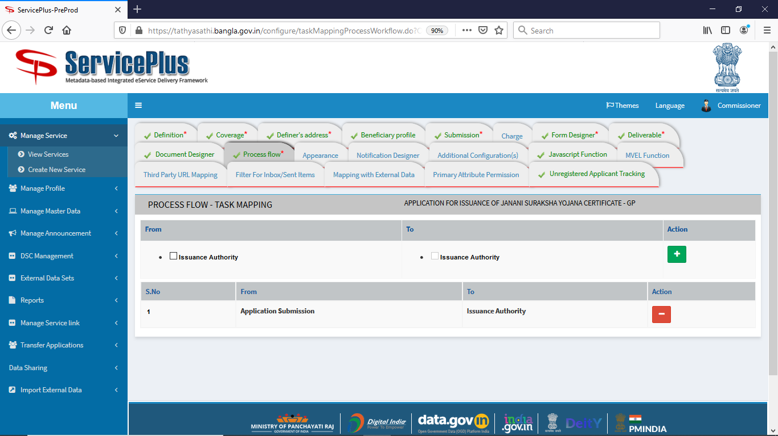

Again go to “Form Designer” tab, click “Add new form template” for “Action Form” as shown below:

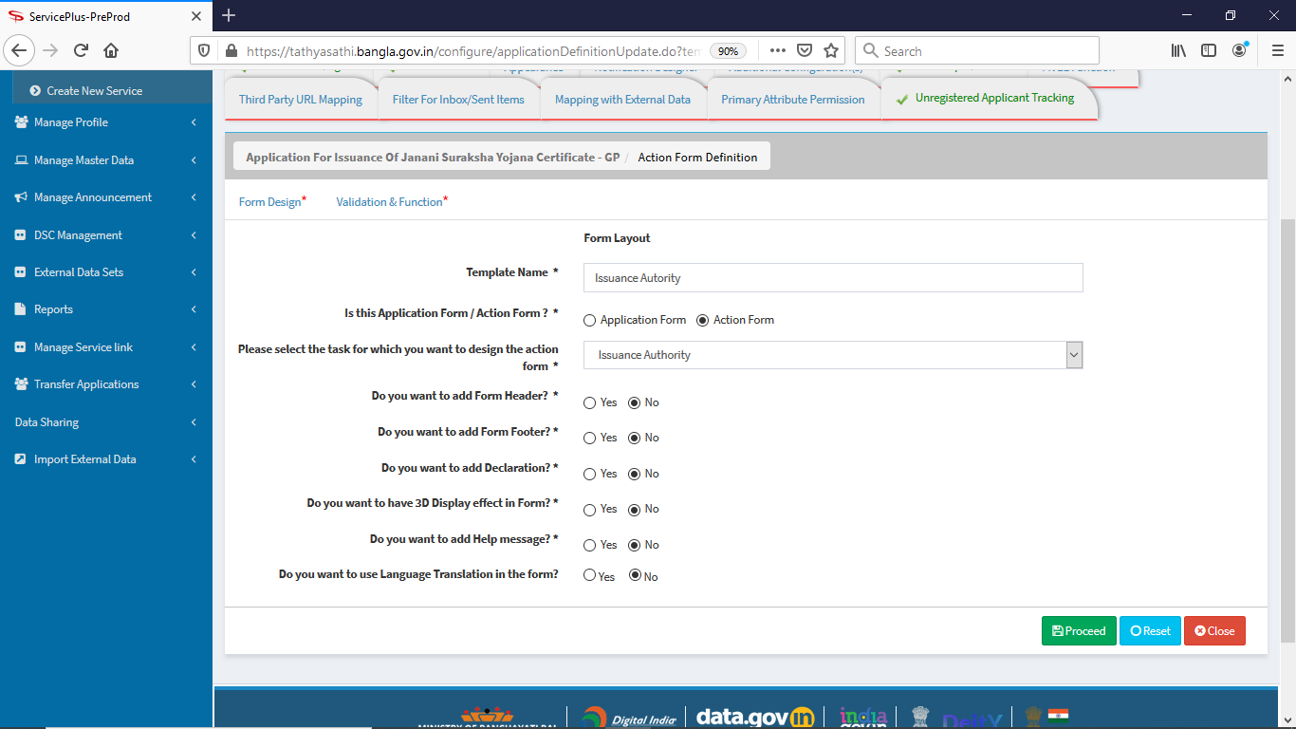

Click “Submit” button.

Action form looks like below. Hidden section will be hidden onloading of the page. ‘Guardian’s Name**‘**, ‘Sex’, ‘Income’ radio is linked with application form ‘Guardian’s Name’& ‘Sex’ radio. ‘Wife of/daughter of’ ‘male/female’ ‘monthly/yearly’ textbox will be filled data ‘wife of’ when Husband is checked & ‘daughter of’ when ‘Father’ is checked using the JavaScript code. ‘Sex’ (male/female) & ‘Income’ (monthly/yearly) use same logic mention in ‘Guardian’s Name**‘**.

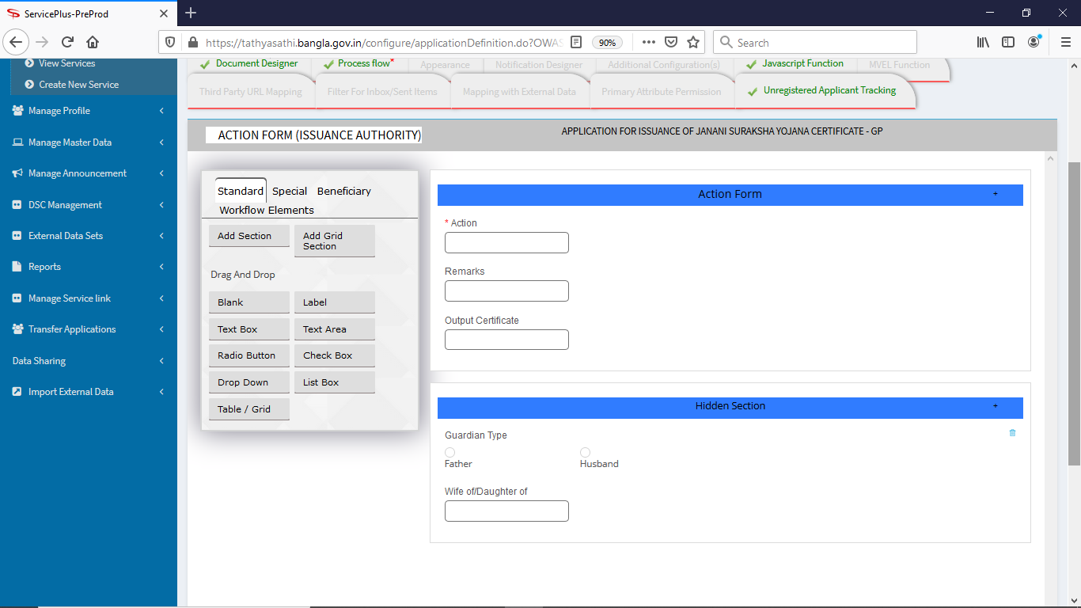

Click “Save” button.

In “Javascript Function” tab click “Create Javascript Function” for Getting Gram Panchayat value, in text box of ‘Gram Panchayat’ label in Application form. Code is as shown below:

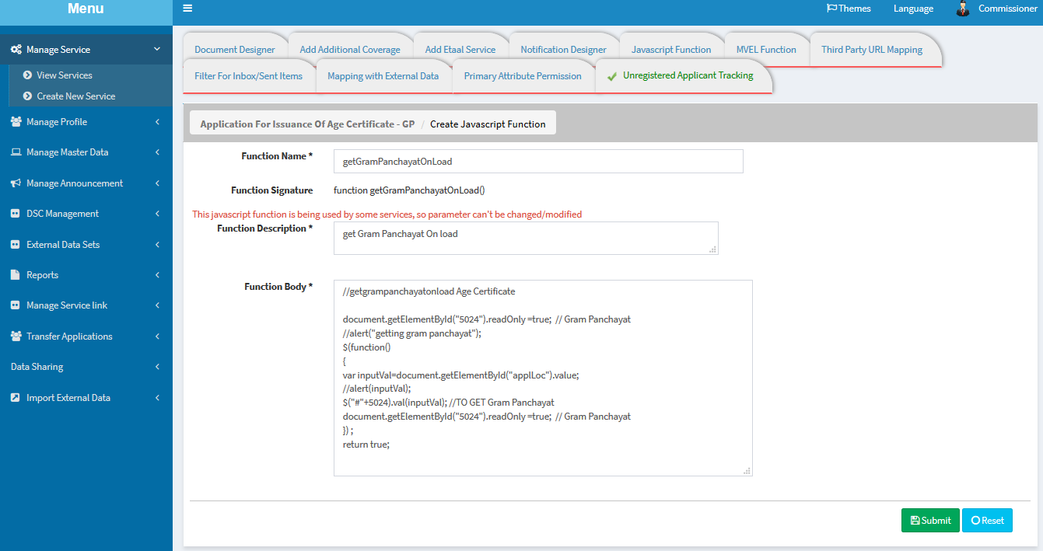

Click “Submit”

Create another js service function: On change ‘Guardian’s Name**,** Father/ Husband, label of textbox ‘Name of Applicant’s Father’ / ‘Name of Applicant’s Husband’ in application form will be shown respectively. Code is as shown below. Click “Submit” button.

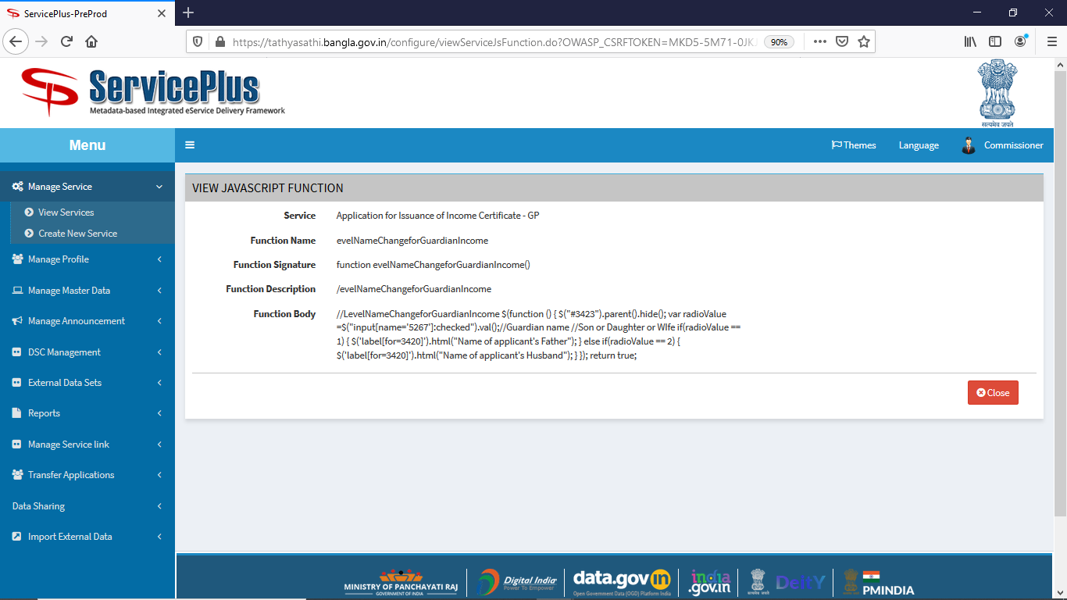

Create another js function: on load application form ‘Name of Applicant’s Father’ & ‘Name of Applicant’s Husband’ textbox will hide in application form. Click “Submit” button.

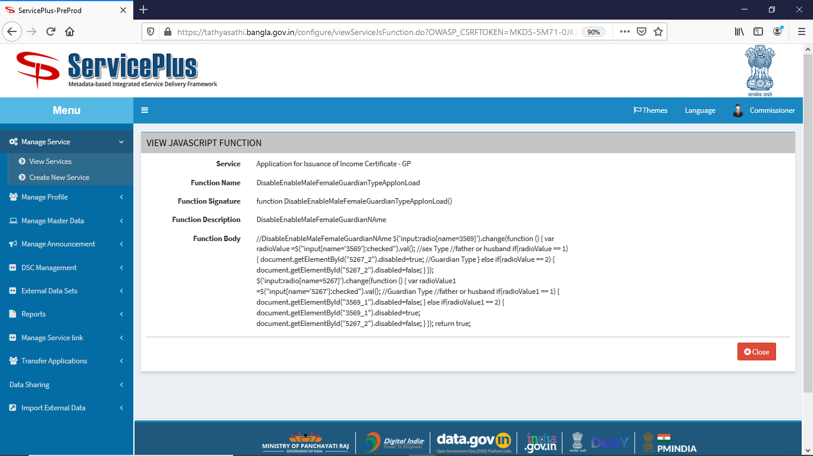

Create another js function : on load action form, to send the value of ‘Wife of/ Daughter of’ textbox to the output certificate, as chosen ‘Guardian’s Name’ , ‘Sex’ and ‘Income’ radio with Bengali script ‘Husband/ Father’ in application form.

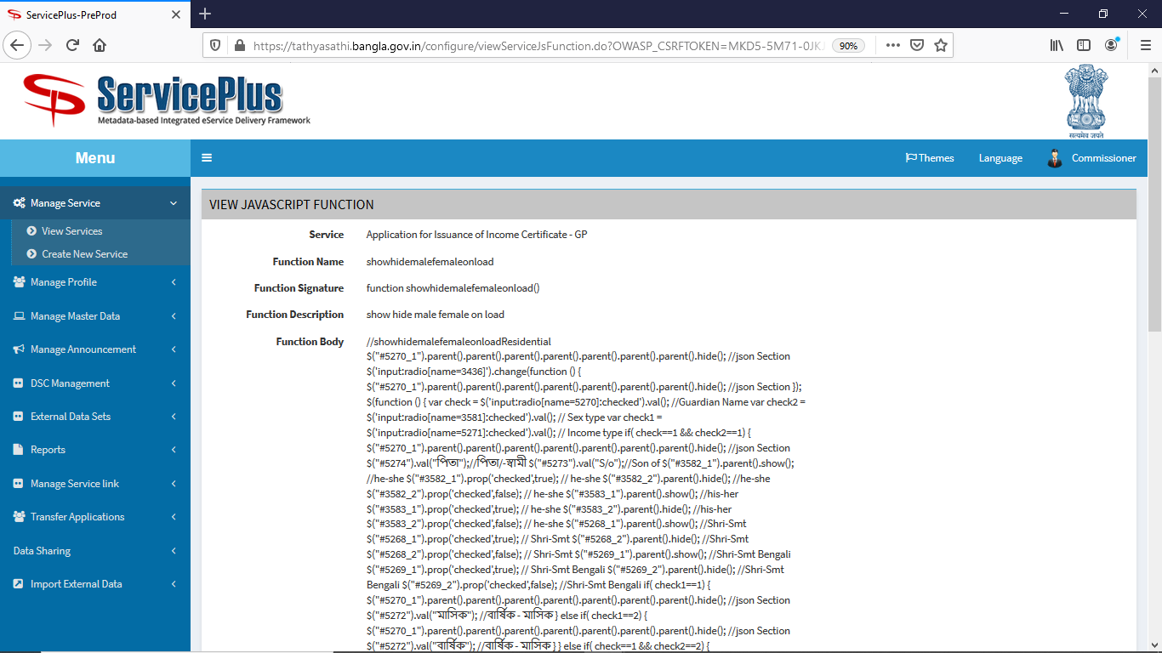

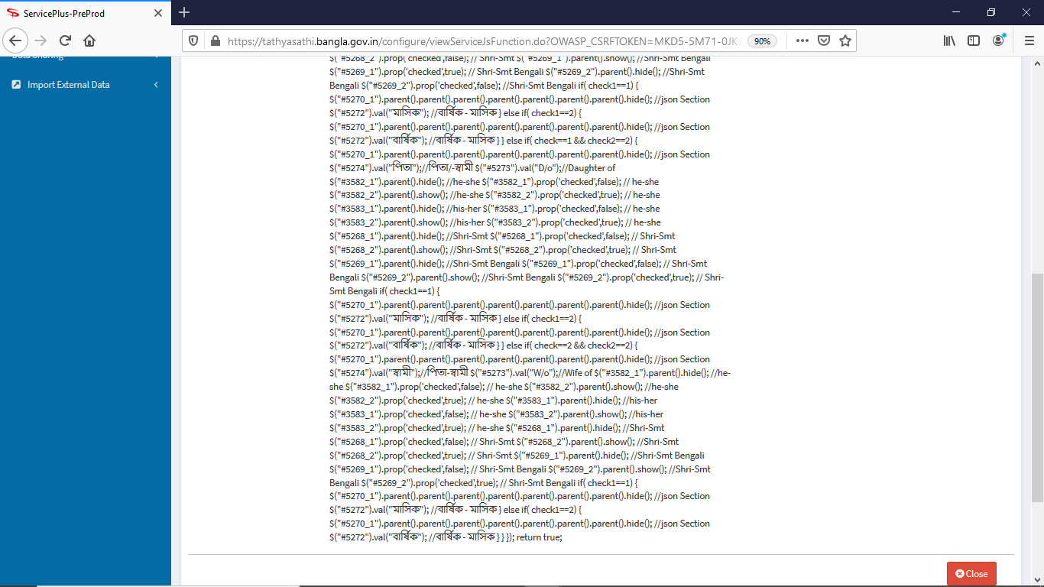

Create another js function : on key up of ‘Name of Village, Name of P.O., Name of P.S. Document No. etc. all input text field ’ for special character validation restriction without Comma as shown below:

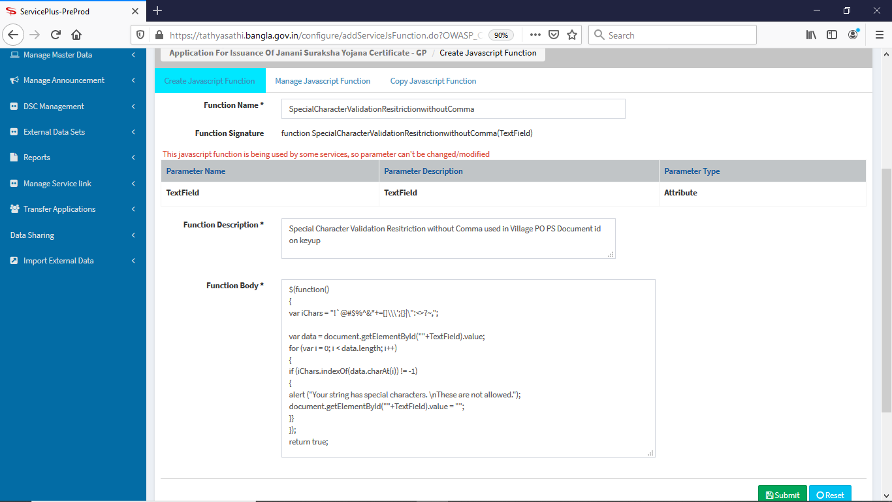

Create another js function : on keypress all input writable fields in application form are being restricted with keyword('insert', 'delete', 'update', 'script', 'JavaScript', ' js ', 'php', 'java' ).

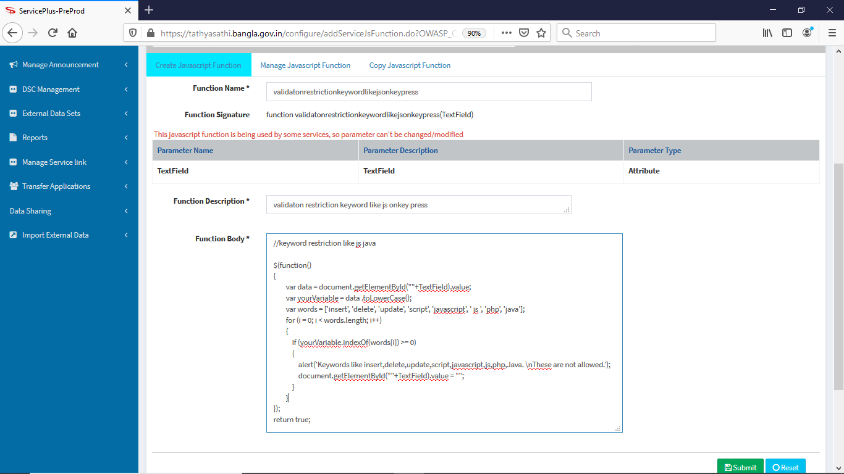

Now go to “Form Designer” tab; click ‘Modify’ on ‘Application form’ (Template Name) then click “Validation & Function*” menu. Generate js function accordingly shown below:

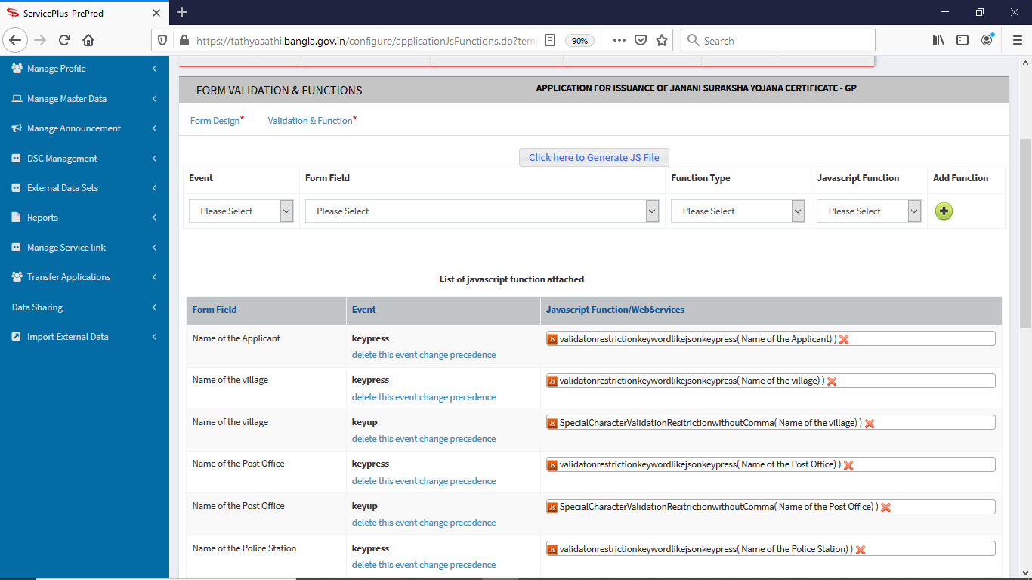

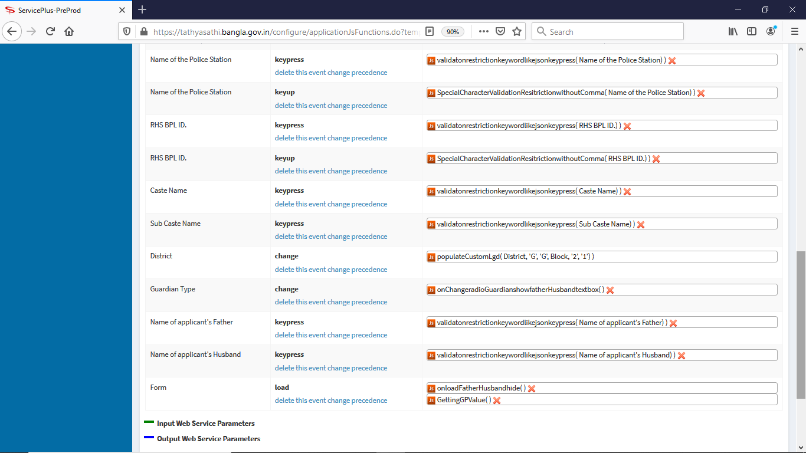

Now click “Click here to Generate JS File”

In “Form Designer” tab; click ‘Modify’ on ‘Issuance Authority’ (Template Name) then click “Validation & Function*” menu. Generate js function accordingly shown below:

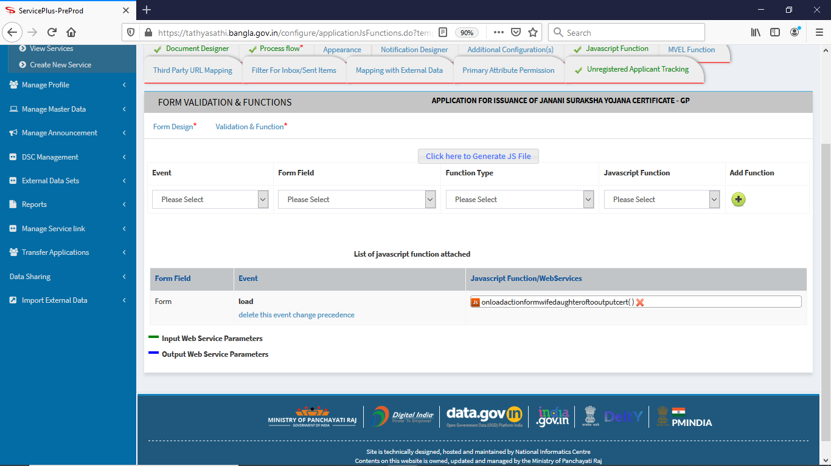

Now click “Click here to Generate JS File”

Activate the service with Login Id as “WB000179” & password as “Bengal@123” . “Select Service” Name as “Application for Issuance of Income Certificate - GP”. Then click “Assign Officials” for assign the service role accordingly to ‘CHAIRMAN’ & ‘Data Entry Operator’. Click the link & pop-up radio & active as under: Then click “Submit” button.

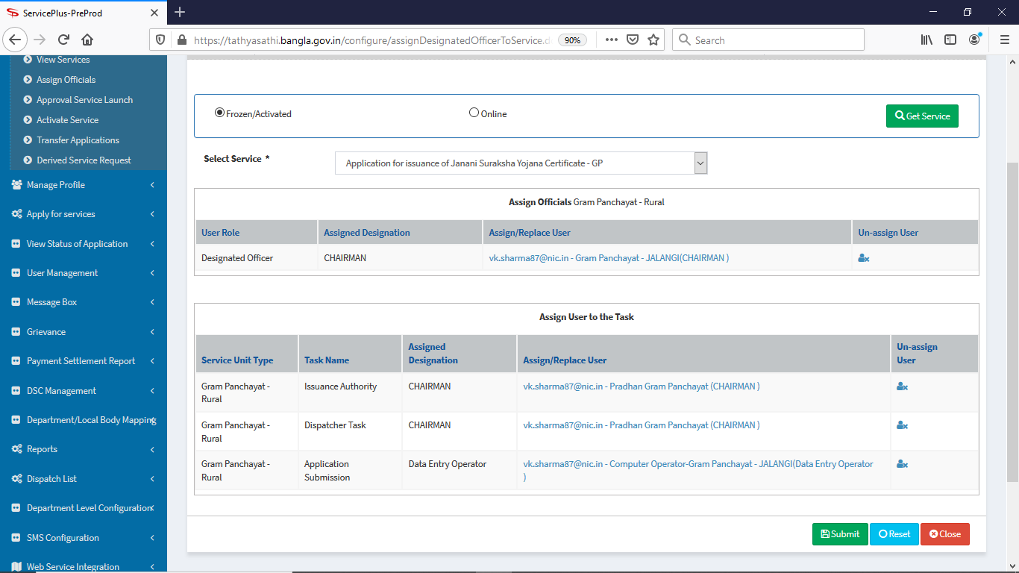

After that click “Activate Service” then click “Modify” section of “Application for Issuance of Income Certificate - GP” then fill up the page as under:

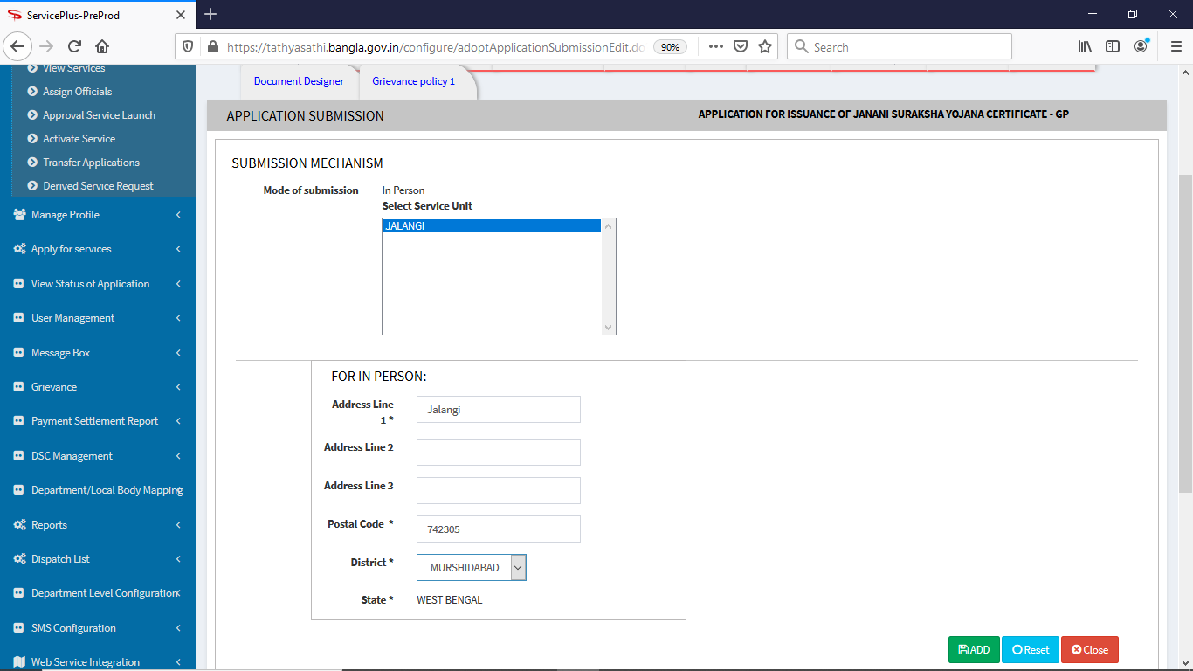

Click “Add” button.

Then again Click on “Activate Service” and click “change” of the ‘Status’ section of “Application for Issuance of Income Certificate - GP” & filled up as shown below, then checked on “Activate/Deactivate” section & click “Submit”

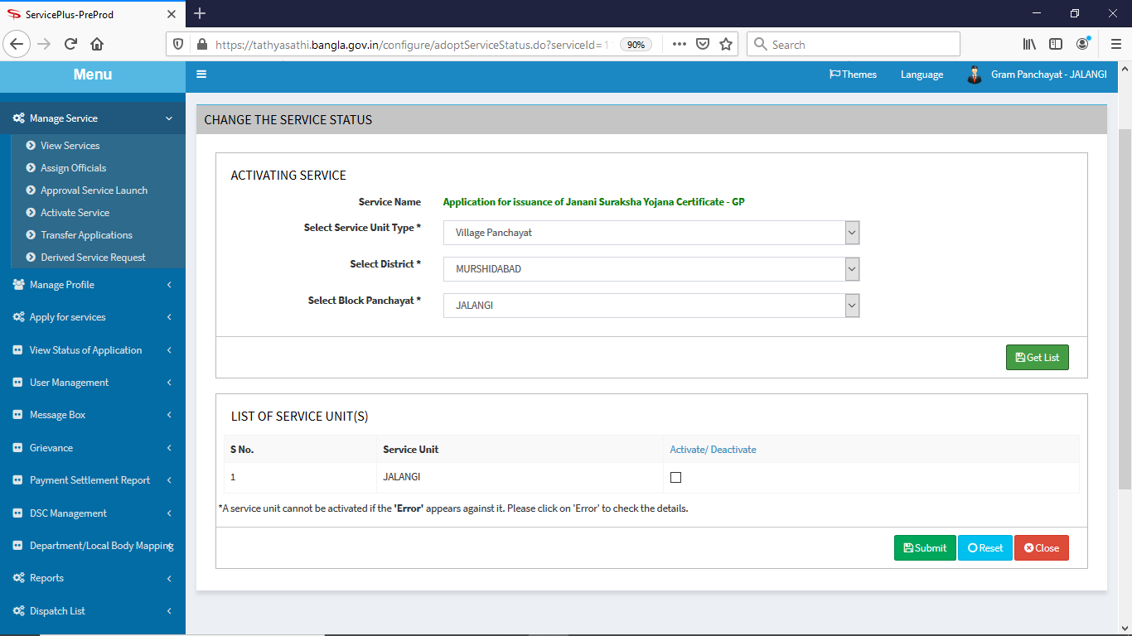

Now the Service “Application for Issuance of Income Certificate - GP” is ready.